Program incorrectly printing multiple times to both screen and file due to misplaced while loop.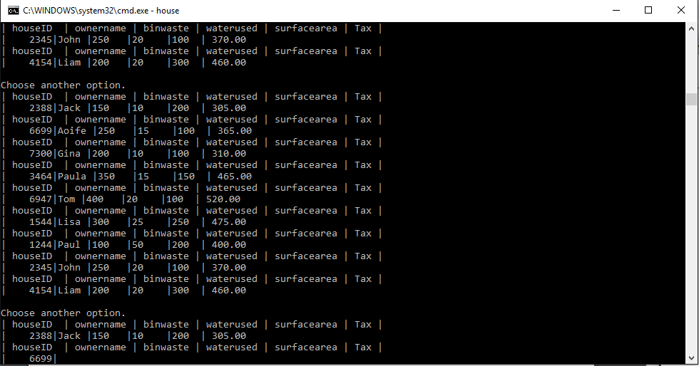

Program correctly printing table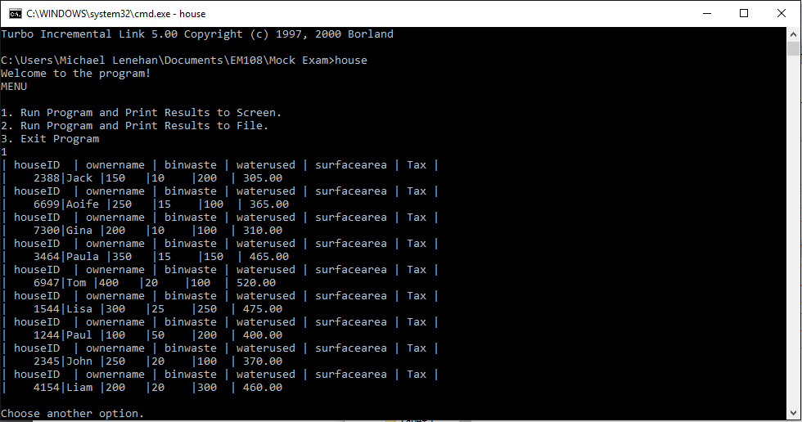

Correctly Printing table to file.

